**Aero2Astro**

**Task 7**

**Part 2**

**Report**

**By**

**Anshul Singh**

**Research intern-Inspect**

**PAPER 9**

**Building Crack Inspection using Small UAV**

The objective of this paper is to build a UAV for the crack detection.

**Methodologies:**

This paper intends to use the changes in the brightness in the gray scale image which is produced by pre-recorded video.

**Image Processing**

This paper takes the image and changes it to gray scale image. It uses canny edge detector for the detection of crack in the infrastructure.

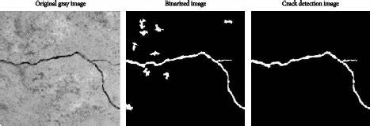

No Dataset is talked about in this paper

**Conclusion**

In this study, a design of the small aerial vehicle-based image acquisition system for inspection of structures was suggested but the image detection technique was not good enough which can help us.

**PAPER 10**

**Development of proactive risk-based inspection and management technology for the wind turbine system**

The paper is focuses on making a inspection and management system for the application of the wind turbine system.

**Algorithm used:**

* SVM
* Adaptive Networked-based Fuzzy Inference System (ANFIS)

**Some Points:**

* This paper divides fault detection as classification problem and uses svm
* It is stating to make the fault detection as the multi class classification problem.
* SVM has competitive advantages as compared to neural network
* For each trial, the ANNs and SVMs are trained with a subset of the experimental data for known machine conditions. The trained ANNs and SVMs are tested using the remaining set of data.

**Tool Used:**

**MATLAB**

**Conclusion:**

This paper focuses on both SVM and ANN for the fault detection.

**PAPER 11**

**Automatic Detection of Wind Turbine Blade Surface Cracks Based on UAV-taken Images**

**Objective:**

In this paper, a data-driven framework is proposed to automatically detect wind turbine (WT) blade surface cracks based on images taken by unmanned aerial vehicles (UAVs).

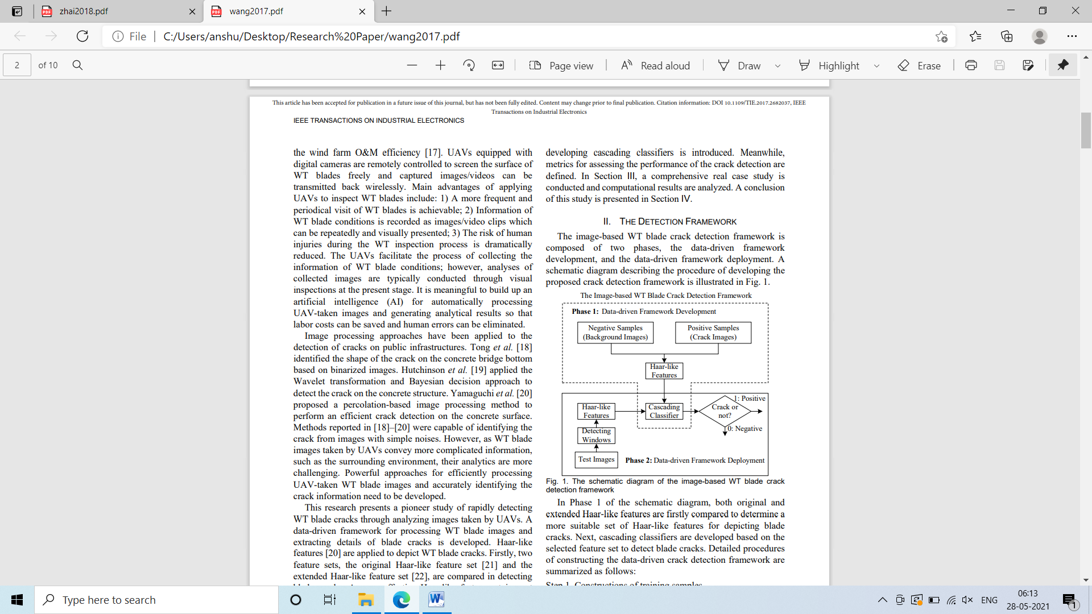

**Algorithm Used**

1. Logitboost Cascading classifier
2. Extended Cascading classifier

**Some Points:**

1. This used haar features in the image pre-processing step.
2. The cascading classifier is made using SVM and DT.

**Performance Measure:**

To assess the effectiveness of the proposed framework, three metrics, the detection rate (DR), false alarm rate (FR), and accuracy (AC).

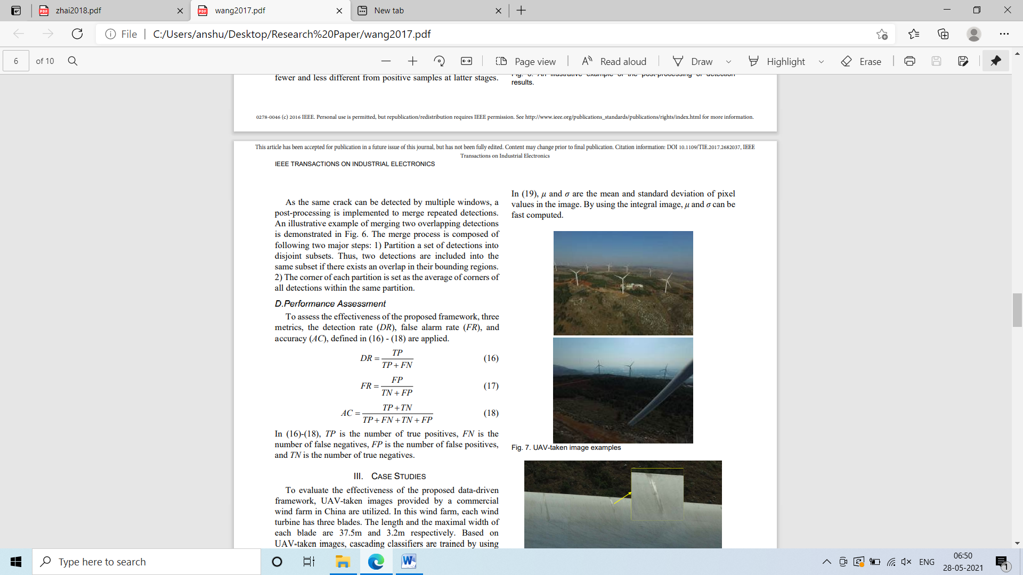

**Results:**

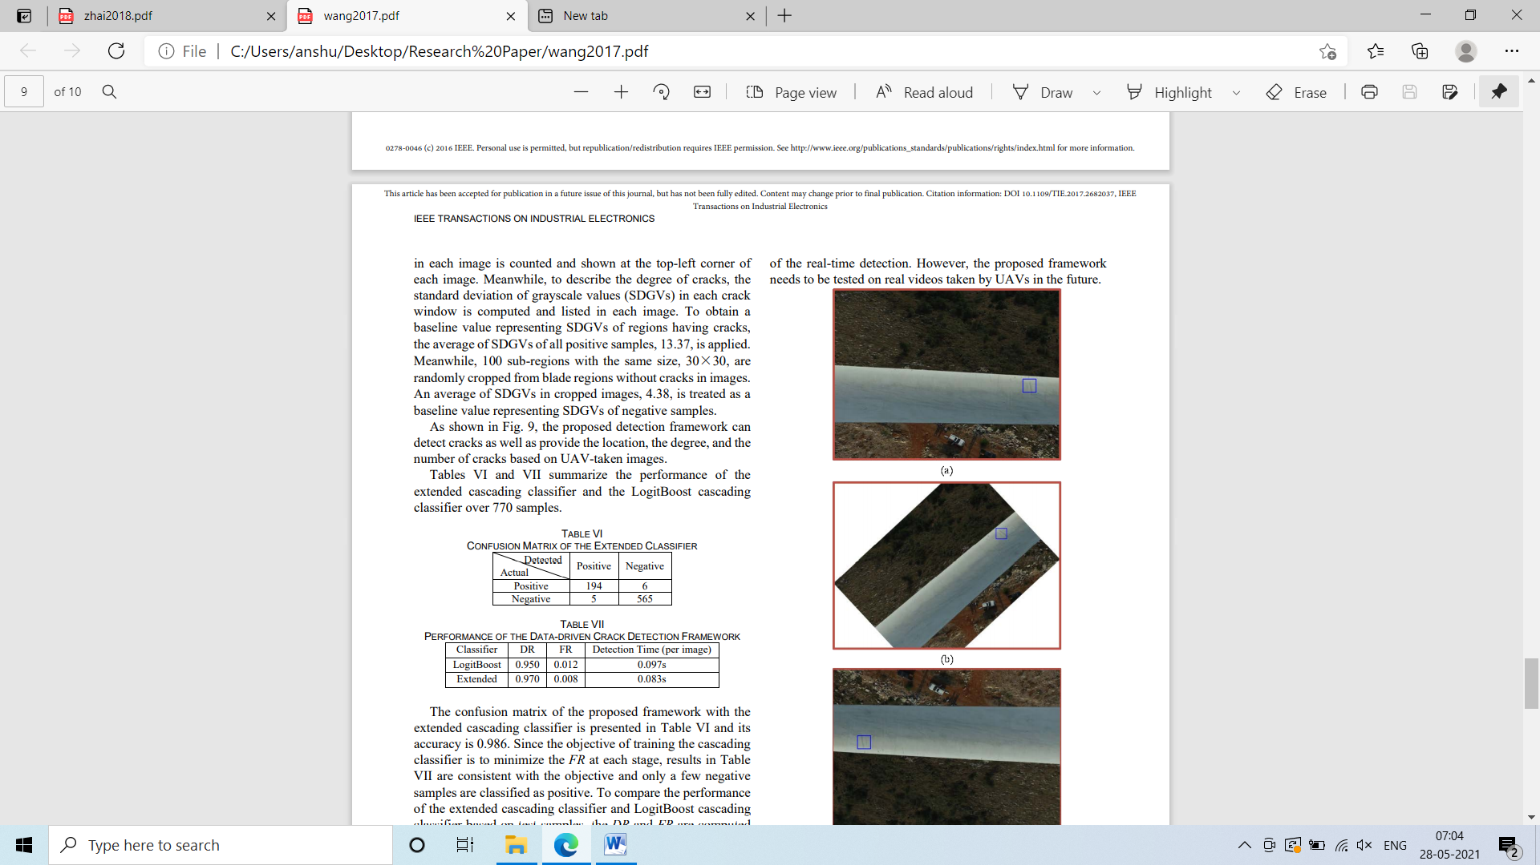

**PAPER 12**

**Insulator Fault Detection Based on Spatial Morphological Features of Aerial Images**

The main aim of this paper is to detect insulator faults using aerial images

As the detection they have used following steps:

1. Color Determination
2. NOISE FILTERING AND TILT CORRECTION
3. SPATIAL FEATURES OF INSULATORS
4. Locate insulator

**Some points:**

1. Morphological processing is used.

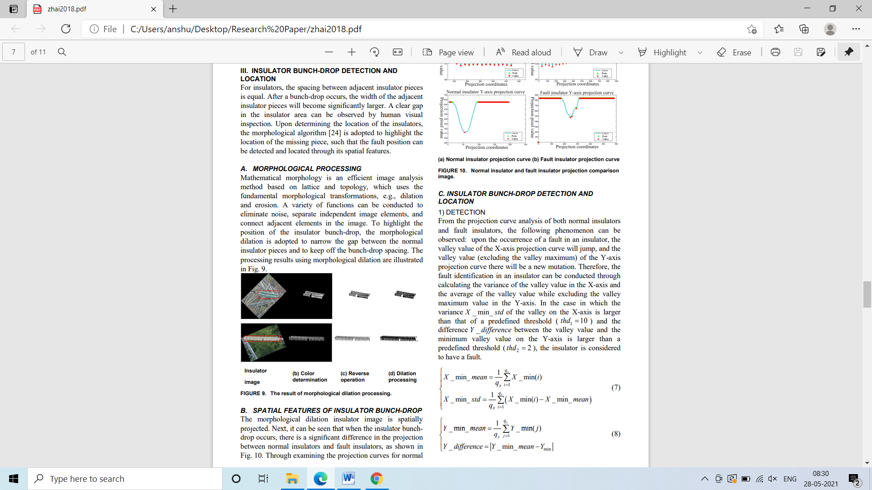

1. No dataset is talked about in this

**Conclusion:**

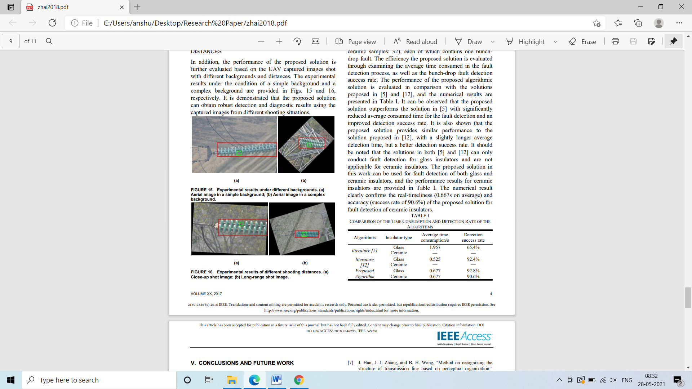

**PAPER 13**

**Mask-MRNet: A deep neural network for wind turbine blade fault detection**

In this paper, a deep neural network named Mask-MRNet is proposed to detect wind turbine (WT) blade fault based on images taken by unmanned aerial vehicles.

**Dataset:**

1. WTB-FMD
2. WTB-FCD

**Architecture used**

Mask MR NET

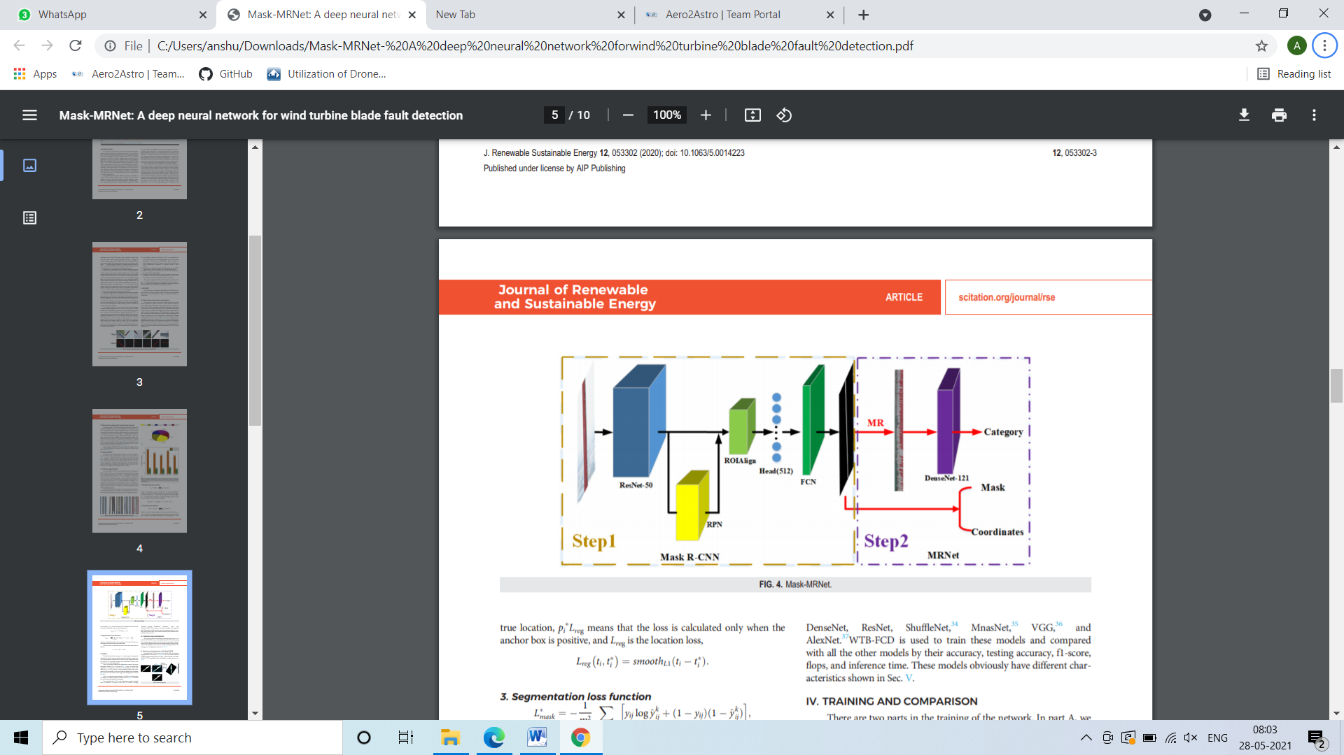

**Some Points:**

* We used Mask R-CNN as an advanced feature extractor for the WT blade, which can not only get the bounding box but also get the corresponding mask of the faults.
* Faults are classified in following classes:

1. **Normal**
2. **Erosion**
3. **Gelcoat off**
4. **Oil Strain**
5. **Paint off**

**HyperParameter of Mask RCNN**

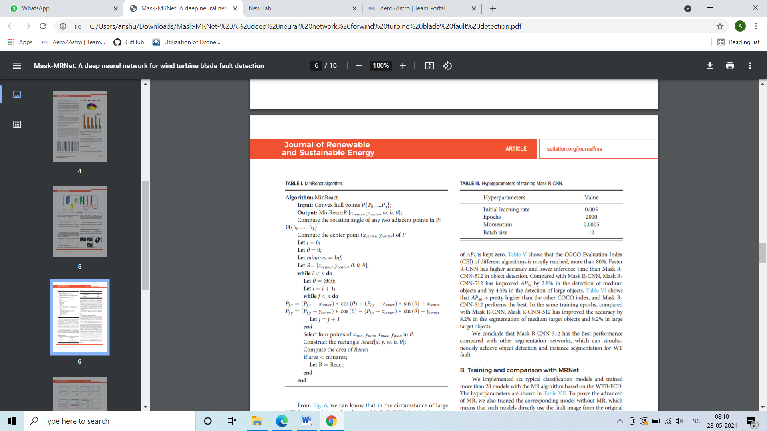

**Conclusion:**

